**There are no ancient Jewish cities in Israel,...  
but there are lots of ancient Greek cities.**

What is weird is this; that 2000 years ago, it seems that there were no people even resembling Jews, in Israel.

It turns out that there is not a single ancient Jewish city in what is now called Israel. There is not a single ancient city where Hebrew characters are used on the statues and buildings. There is not a single ancient city where the buildings are in the ancient Jewish architectural style. In fact, there is not even a category of "ancient Jewish architectural style".

Of course, the Hebrew characters that are desired, are those of the Dead Sea scrolls (supposedly from 2000 years ago), which are essentially the modern Hebrew characters without points.

If you check out all the ancient cities in Israel from 2000 years ago, they are all Greek, and their ruins are still there for you to visit. Their inscriptions are in the Greek script and the buildings are in the ancient Greek architectural styles.

Here is a list of some of the known ancient Greek cities in (and near) Israel; Ecdippa, Seleucia, Ptolemais, Taricheia Arbela, Asochis, Sepphoris, Hippos, Dion, Sycaminum, Bucolon Polis, Itabyrium, Gadara, Abila, Dora, Comus, Gephrus, Crocodilion Polis, Caesarea, Straton's Tower, Narbata, Scythopolis, Pella, Samaria, Amathus, Ragaba, Gerasa, Apollonia, Sicima, Pegae, Joppa, Arimathea, Jamnia, Port of Jamnia, Lydda, Modiin, Aphaerema, Philadelphia, Birtha, Gazara, Beth Horon, Dok, Jericho, Samaga, Esbus, Medaba, Ladder of Tyre, Azotus, Port of Azotus, Accaron, Jerusalem, Ascalon, Anthedon, Gaza, Marissa, Beth Zur, Hebron, Adora, Engeddi.

**The ancient Jewish cities in Israel are,....... well there aren't any. Not even one.**

Here's an interesting example of a first century BC **Greek inscription** (i.e., in Greek letters) **from Jerusalem's Temple Mount** forbidding the entry of strangers to the Temple precinct.

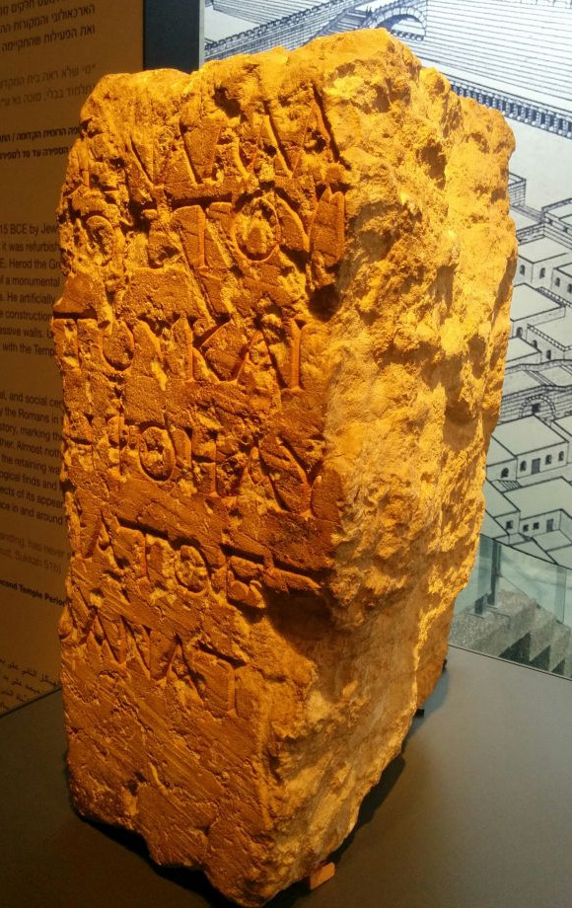

<http://www.preearth.net/images/no-foreigner-shall-enter.jpg>

The pictured stone was found in 1935. It was actually the second such warning-stone to be found, the first being discovered by Charles Simon Clermont-Ganneau in 1871. It was deemed so dangerous to the "Jews inhabited Israel 2000 years ago" theory, that it completely disappeared for 13 years before resurfacing in Istanbul, where, it was correctly calculated, it would not attract much attention.

From: [https://www.timesofisrael.com/ancient-temple-mount-warning-stone-is-clo…](https://www.timesofisrael.com/ancient-temple-mount-warning-stone-is-closest-thing-we-have-to-the-temple/)

The first **Jerusalem Temple Mount** warning-stone, now found in the Archaeology Museum, Istanbul, is pictured below:

<http://preearth.net/images/jerusalem-temple-warning-at-istanbul.jpg>

It says (in Greek): "No stranger is to enter within the balustrade round the temple and enclosure. Whoever is caught will be responsible to himself for his death, which will ensue."

**Slack Jack's CHALLENGE:**

Name **ONE** ancient city (that existed in what is now called Israel) where the building inscriptions are all in Hebrew, and the buildings are constructed in the ancient Hebrew architectural style (whatever that may be).

Then give a summary of "the ancient Hebrew architectural style" (you will have to make this up as it does not yet exist).

Then give links to photos of the ancient building inscriptions which show that they are written in Hebrew.

Then show that the buildings are constructed in the ancient Hebrew architectural style (that you have just invented).

<http://www.preearth.net/phpBB3/viewtopic.php?f=23&t=1175>

css1971 Jan 19, 2018 3:50 AM "The concept of jewishness didn't exist in ancient history, the God of the bible was EL. And El was the head of a pantheon of God's which were worshipped in the Levant and further by many different people."

El = Ηλ is a name of the Greek sun God.

El = Ηλ = Ηλοσ = Ηλιοσ = Ηελιοσ = the Greek sun God.

Without the capital letter el = ηλ is the Greek word for the sun.

Daniel = Δανιηλ = Δαν/ηλ = Dan/el = roof of the sun  
Michael = Μιχα/ηλ = Μυχα/ηλ = μυχο/ηλ = center of the sun  
Nathanel = Ναθαν/ηλ = αθανα/ηλ = ανασαν/ηλ = breath of the sun  
Raphael = Ραφα/ηλ = Rapha/el = Ripe/el = ριπη/ηλ = ray of the sun  
Iezekiel = Ιεζεκιηλ = Ιεζ/εκ/ηλ = υιος εξ Ηλιου = son of the sun  
Ismael = Ισμα/ηλ = Σιμα/ηλ = σημα/ηλ = mark of the sun  
Emmanuel = Εμοι/εν/Ηλ = Εμοι (me) εν (within) Ηλ (God) = God is with me  
Israel = Eis/ra/el = εις (mighty) + ρα (king) + ηλ (sun) = mighty sun God

These have been gathered from the internet.

css1971 Jan 19, 2018 3:50 AM "The concept of jewishness didn't exist in ancient history, the God of the bible was EL. And El was the head of a pantheon of God's which were worshipped in the Levant and further by many different people."

El = Ηλ is a name of the Greek sun God.

El = Ηλ = Ηλοσ = Ηλιοσ = Ηελιοσ = the Greek sun God.

Without the capital letter el = ηλ is the Greek word for the sun.

Daniel = Δανιηλ = Δαν/ηλ = Dan/el = roof of the sun  
Michael = Μιχα/ηλ = Μυχα/ηλ = μυχο/ηλ = center of the sun  
Nathanel = Ναθαν/ηλ = αθανα/ηλ = ανασαν/ηλ = breath of the sun  
Raphael = Ραφα/ηλ = Rapha/el = Ripe/el = ριπη/ηλ = ray of the sun  
Iezekiel = Ιεζεκιηλ = Ιεζ/εκ/ηλ = υιος εξ Ηλιου = son of the sun  
Ismael = Ισμα/ηλ = Σιμα/ηλ = σημα/ηλ = mark of the sun  
Emmanuel = Εμοι/εν/Ηλ = Εμοι (me) εν (within) Ηλ (God) = God is with me  
Israel = Eis/ra/el = εις (mighty) + ρα (king) + ηλ (sun) = mighty sun God

These have been gathered from the internet.

[Dr. Yzterbaard](https://www.zerohedge.com/users/dr-yzterbaard) [Slack Jack](https://www.zerohedge.com/users/slack-jack) Jan 19, 2018 2:00 AM [Permalink](https://www.zerohedge.com/comment/11024882#comment-11024882)

Idreal Finkelstein, Professor if Archaeolgy, Tel Aviv U, stated that not a single archaeological fragment proving a single Old Testament event, character ir city has ever been unearthed, rendering the entire OT ‘history’ a myth, fabrication or retelling if other civilization stories  his book ‘the Bible Unearthed’ is a massive wake-up call to what is true and what is bs

<https://en.wikipedia.org/wiki/The_Bible_Unearthed>

**[Vote down!](https://www.zerohedge.com/vote/comment/11026451/-1?token=H9zkWYtp2fA1jCJWmTB7xB-a6CqVWS1iTNABJCDSngQ" \o "Vote down!)**

2

[(reset)](https://www.zerohedge.com/votereset/comment/11026451?token=Zw3La0L8buepIDpkZg8YpAyXVwH2fsfvw9taTzEVChg" \o "Reset your vote)

[Profile picture for user Pope Clement](https://www.zerohedge.com/users/pope-clement)

[Pope Clement](https://www.zerohedge.com/users/pope-clement) [Slack Jack](https://www.zerohedge.com/users/slack-jack) Jan 19, 2018 10:55 AM [Permalink](https://www.zerohedge.com/comment/11026451#comment-11026451)

Thank you Slack. The douchebag ignorami down voters don’t have a clue of the lies and deceptions and mind control that Have been inflicted on humanity for many centuries by the elitist psychopath oppressors of the Vatican and Royal houses. Much of history was invented around the time of the Gregorian calendar update where a thousand ghost years were    Inserted into this new calendar and events of late medieval times were transposed back to a newly invented clsssical age. To begin toget a handle on the extent of the deceptions start with the Russian and German chronologists and historians such as Anatly Fomenko and the interdiciplinarian scholars from Moscow State University where you find overwhelming evidence that a vast swath of old Russia was called Israel and Turkey was known as Judea. Much of Fomenko’s massive multi volume work is now available in English. Highly recommended for your intellectual delectation and unshackling the insidious mind control....

* [reply](https://www.zerohedge.com/comment/reply/node/611194/comment/11026451)

In reply to ["Explosive", "Shocking" And …](https://www.zerohedge.com/comment/11024417#comment-11024417)by [Slack Jack](https://www.zerohedge.com/users/slack-jack)

**[Vote up!](https://www.zerohedge.com/vote/comment/11026651/1?token=uFZT1NfBdDEcl7g_3xoSmhZQ2rQLUJznf08evP8BA0Q" \o "Vote up!)**

2

**[Vote down!](https://www.zerohedge.com/vote/comment/11026651/-1?token=d6pNTXcWBM6tGDOByPJ3_wQmKeuZ3JNixIbD7Ec4DjU" \o "Vote down!)**

0

[(reset)](https://www.zerohedge.com/votereset/comment/11026651?token=4eqGpn9UnGQZTpgzeU8220GIHsfE_JZnO3Y8a3aN55E" \o "Reset your vote)

[Profile picture for user JRobby](https://www.zerohedge.com/users/jrobby)

[JRobby](https://www.zerohedge.com/users/jrobby) [Pope Clement](https://www.zerohedge.com/users/pope-clement) Jan 19, 2018 11:26 AM [Permalink](https://www.zerohedge.com/comment/11026651#comment-11026651)

Re-Writing the Bible has had massive economic windfall for certain control groups.